Letter of Medical Necessity Checklist
In the following document you will find a checklist and sample Letter of Medical Necessity. Please use this checklist as a guide while completing your patient’s individualized LOMN. You will need to customize and fill this out appropriately for each patient. Please note that all fields that require customizations are red and will need to be modified as the prescriber deems appropriate.
Please ensure the following are present on every Letter of Medical Necessity
- Patient First & Last Name
- Date of Birth
Patient’s Clinical History
- All pertinent diagnoses that convey the need for RELiZORB
- Include the diagnoses of “EPI”, “malabsorption”, “malnutrition”, if applicable
- Note the therapies tried, how they were administered (orally or added to formula), the name(s) of PERTs used and the evidence of treatment failure
- If RELiZORB trialed, please note symptom improvements, weight change, BMI change, if applicable
Treatment Plan
- Reference any additional guidelines, clinical studies tied to the patient’s clinical presentation
- Note number of cartridge(s) required
Summary
- Medical necessity criteria and hazards to health if continues a failed therapy
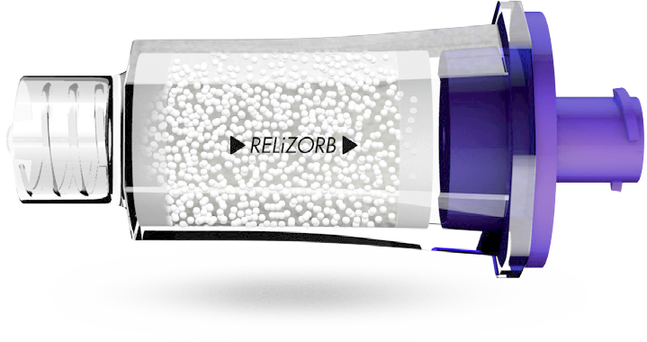
Attachments
Please include the following with the Prior Authorization packet
- Clinic visits in the last 6 months
- RD Nutrition notes from the last 6 months
- Growth charts – height, weight, BMI, weight for length (if applicable)

FOR ANY QUESTIONS: PLEASE CALL RELiZORB SUPPORT SERVICES AT 1-844-632-9271

Date:
Member Name:
Member ID:
DOB:

Dear Medical Director,

I am writing on behalf of my patient, <patient name>, to document medical necessity for treatment with RELiZORB® (iMMOBILIZED LIPASE) CARTRIDGE and request individual consideration of my patient’s case. This letter provides information about <patient name>’s clinical history and the evidence-based treatment plan I have prescribed. On behalf of my patient, I am requesting approval and subsequent payment for treatment with RELiZORB.
Patient’s Clinical History
<Patient name> is a <age>-year-old <male/female> with a history of <add pertinent diagnoses, malabsorption/exocrine pancreatic insufficiency and G tube dependency>. Due to <his/her> diagnoses, <patient name> requires enteral tube feedings for supplemental nutrition. In the past, <patient name> has received pancreatic enzyme replacement therapy (PERT) <method of enzyme delivery with tube feedings>. With this method of enzyme delivery, <patient name> suffers from < GI symptoms experienced>.

PERT (pancreatic enzyme replacement therapy) products are intended for use with oral meals mostly consisting of solid foods, and there is no data regarding the safety and efficacy of PERT use with enteral nutrition. Patients receiving enteral nutrition were actually excluded from clinical trials which led to FDA approval of PERTs (i). Since <patient name> receives enteral nutrition overnight while sleeping, there is no practical, safe, effective way to deliver a pancreatic enzyme product during the overnight feeding outside of RELiZORB use.
Exocrine Pancreatic Insufficiency
EPI occurs when secretions of the pancreas do not maintain normal digestive function, resulting in nutrient malabsorption and other symptoms such as diarrhea, abdominal pain, bloating, nausea and constipation which in turn affects quality of life and eventually results in malnutrition (i). There are multiple etiologies of EPI including but not limited to cystic fibrosis, chronic pancreatitis, acute pancreatitis, diabetes mellitus, pancreatic cancer, pancreatic duct obstruction, Celiac disease, Crohn’s disease, Shwachman-Diamond syndrome, gastrectomy, small bowel resection and short bowel syndrome (i).

Regardless of the etiology, all individuals with EPI require pancreatic enzyme treatment in order to absorb fats in their diet. Fatty acid absorption is essential in nutrition, primarily as energy sources and membrane constituents but also in biological activities that influence cell and tissue metabolism, function and responsiveness (ii).

Treatment Plan
RELiZORB is an FDA approved, single-use digestive enzyme cartridge designed to hydrolyze fats in enteral formula for individuals who require enteral nutrition and who do not excrete adequate amounts of the digestive enzyme lipase. RELiZORB connects in line with the feeding tube set and allows lipase to be present during the entire tube feeding process, hydrolyzing the fat in the enteral formula. As formula flows through the RELiZORB cartridge, the fats in the formula are broken down by the enzyme lipase and converted to readily absorbable fatty acids and monoglycerides.
Clinical trials evaluated short-term and long-term use of RELiZORB, and studies were published in peer-reviewed journals. The three studies demonstrated the following (iii, iv, v) -

- Hydrolysis of fat in formula
- Normalization of plasma DHA/EPA fatty acid levels, (from <60% of normal at baseline to statistically significant improvements into the range of healthy individuals (2.8 fold improvement) (iii)
- Statistically significant 2.2 fold Improvement in red blood cell DHA and EPA composition a surrogate for longer term tissue uptake reaching levels found in healthy individuals. (iv)
- Reduction in adverse gastrointestinal symptoms associated with EPI, across all studies (iii, iv, iv)
- Improved weight z-scores in 2 long-term studies [3 months (iv) and at 6 and 12 months(v)].
- Statistically significant improvements in: weight, weight z-score and percentiles; height, height z-score and percentiles, at 6 months (v).
- At 12 months, statistically significant improvements in height, weight and weight z-scores and a high trend towards clinically significant improvements in BMI z-score at 1 year (v)

Summary
Due to <his/her> medical condition, <patient name> requires lipase supplementation and requires tube feedings to <treat/prevent> malnutrition. Without insurance approval, <patient name> will not have access to RELiZORB, putting my patient at risk for poor outcomes including <worsening diarrhea, dehydration, further weight loss and hospital admission>.

I strongly believe that RELiZORB is essential to <patient name>’s enteral feeding program. It is the only FDA approved treatment option to address malabsorption and its debilitating, life-threatening effects. This device is medically necessary, widely accepted and the only clinically appropriate option for my patient’s current presentation.

If you have any questions, please do not hesitate to contact me. Thank you for your prompt attention to this matter.

Sincerely,

____________________

<MD name/title>

References:
- Fieker A, Philpott J, Armand M. Enzyme replacement therapy for pancreatic insufficiency: present and future. Clin Exp Gastroenterol. 2011;4:55-73.
- Calder, P. Functional roles of fatty acids and their effects on human health. J Parenter Enteral
Nutr. 2015; 20(10); 1-15.
- Freedman, S., et al. Increased fat absorption from enteral formula through an in-line digestive cartridge in patients with cystic fibrosis. J Pediatr Gastroenterol Nutr. 2017;65(1):97-101.
- Stevens J, Wyatt C, Brown P, Patel D, Grujic D, Freedman SD. Absorption and Safety with Sustained Use of RELiZORB® Evaluation (ASSURE) study in patients with cystic fibrosis receiving enteral feeding. J Pediatr Gastroenterol Nutr. 2018; 67(4):527-532.
- Sathe, M., Patel, D., Stone, A., First, E. Evaluation of the effectiveness of in-line immobilized lipase cartridge in enterally fed patients with cystic fibrosis. J Pediatr Gastroenterol Nutr. 2021;72:18-23.

